|  |
| --- |
| Circle Language Spec: Events |

## Explicit Interface of Event Object

The previous article showed how the implementation of an event object explicitly looks. The interface of an Event object, so the part that other objects interact with, looks as follows:

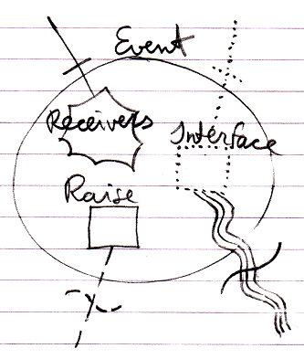

The connectors at the top of the picture are the members that the event *receiver* will interact with: it will *register* its command as a Receiver and it will *implement* the command Interface.

The connectors at the bottom of the picture are the members that the event *sender* will interact with: it will *call* the Raise command of the event and it will also define the *data* that will form the command Interface of the event.